Phonepe Integration

Plugin Integration:

Woocommerce Plugin:

Please find the documentation for Woocommerce Plugin: https://developer.phonepe.com/v1/docs/woocommerce-plugin-1

Test credentials:

MID: PHONEPEPGUAT
Key Index: 1
Key: c817ffaf-8471-48b5-a7e2-a27e5b7efbd3

Please install the Phonepe pre-prod app for testing purposes: https://developer.phonepe.com/v1/docs/setting-up-test-account

Opencart Plugin:
Please find the documentation for Opencart Plugin: https://developer.phonepe.com/v1/docs/opencart-plugin-1

Test credentials:

MID: PHONEPEPGUAT
Key Index: 1
Key: c817ffaf-8471-48b5-a7e2-a27e5b7efbd3

Please install the Phonepe pre-prod app for testing purposes: https://developer.phonepe.com/v1/docs/setting-up-test-account

Website Integration:

Standard Checkout(Website/Pay Page Integration):

(When merchant integrates Pay page with all instruments by default on the website)

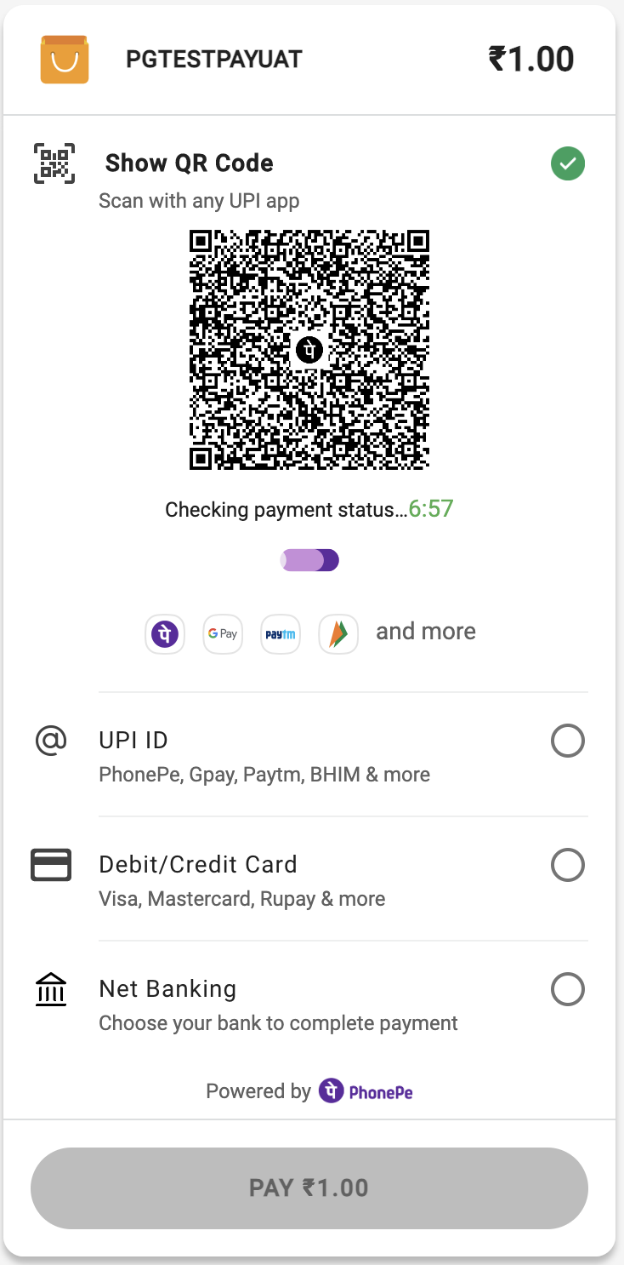

Payment Initiation

Pay API: https://developer.phonepe.com/v1/reference/pay-api#pay-request-for-web-flow

Response Authorization

Check Payment Status - https://developer.phonepe.com/v1/reference/check-status-api

Server-to-Server Response - https://developer.phonepe.com/v1/reference/server-to-server-callback-4

Refund Flow

Refund API - https://developer.phonepe.com/v1/reference/refund-6

Refund Status API - https://developer.phonepe.com/v1/reference/check-status-api

Test credentials:

MID: PHONEPEPGUAT
Key Index: 1
Key: c817ffaf-8471-48b5-a7e2-a27e5b7efbd3

Test card details:

"card_number": "4622943126146407",
"card_type": "DEBIT_CARD",
"card_issuer": "VISA",
"expiry_month": 12,
"expiry_year": 2023,
"CVV": "936",

Bank Page OTP: 123456

Please use UAT Simulator for testing: https://developer.phonepe.com/v1/docs/uat-simulator-1

Custom Checkout:

(When merchants wish to integrate PhonePe at instrument levels like Card, UPI, QR, Collect, or Netbanking)

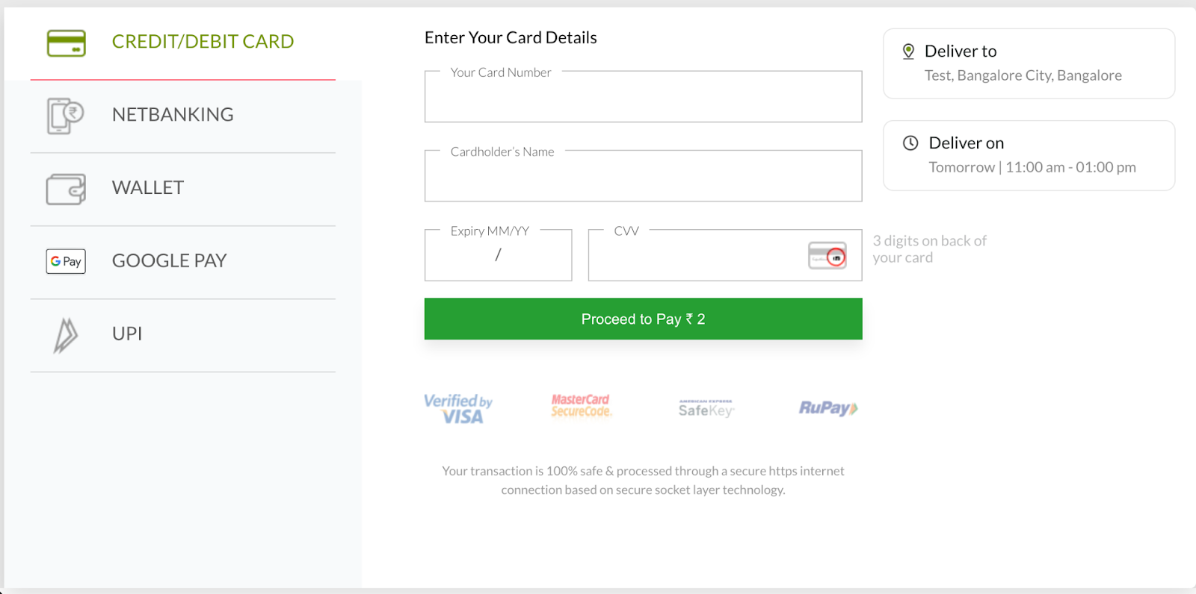

UPI Open Intent:

(This instrument is generally implemented for Android Application integration with Phonepe)

Payment Initiation

https://developer.phonepe.com/v1/reference/pay-api#pay-request-for-upi-open-intent-flow

Response Authorization

Check Payment Status - https://developer.phonepe.com/v1/reference/check-status-api

Server-to-Server Response - https://developer.phonepe.com/v1/reference/server-to-server-callback-4

Refund Flow

Refund API - https://developer.phonepe.com/v1/reference/refund-6

Refund Status API - https://developer.phonepe.com/v1/reference/check-status-api

Test credentials:

MID: PHONEPEPGUAT
Key Index: 1
Key: c817ffaf-8471-48b5-a7e2-a27e5b7efbd3

Please use UAT Simulator for testing: https://developer.phonepe.com/v1/docs/uat-simulator-1

UPI Collect:

(This Payment instrument can be implemented for both website and Android Applications)

VPA validation:

https://developer.phonepe.com/v1/reference/vpa-validate-api

Payment Initiation

https://developer.phonepe.com/v1/reference/pay-api#pay-request-for-upi-open-intent-flow

Response Authorization

Check Payment Status - https://developer.phonepe.com/v1/reference/check-status-api

Server-to-Server Response - https://developer.phonepe.com/v1/reference/server-to-server-callback-4

Refund Flow

Refund API - https://developer.phonepe.com/v1/reference/refund-6

Refund Status API - https://developer.phonepe.com/v1/reference/check-status-api

Test credentials:

MID: PHONEPEPGUAT
Key Index: 1
Key: c817ffaf-8471-48b5-a7e2-a27e5b7efbd3

Please use UAT Simulator for testing: https://developer.phonepe.com/v1/docs/uat-simulator-1

UPI QR:

(This Payment instrument can be implemented only on the website)
Payment Initiation

https://developer.phonepe.com/v1/reference/pay-api#pay-request-for-upi-qr

Response Authorization

Check Payment Status - https://developer.phonepe.com/v1/reference/check-status-api

Server-to-Server Response - https://developer.phonepe.com/v1/reference/server-to-server-callback-4

Refund Flow

Refund API - https://developer.phonepe.com/v1/reference/refund-6

Refund Status API - https://developer.phonepe.com/v1/reference/check-status-api

Test credentials:

MID: PHONEPEPGUAT
Key Index: 1
Key: c817ffaf-8471-48b5-a7e2-a27e5b7efbd3

Please use UAT Simulator for testing: https://developer.phonepe.com/v1/docs/uat-simulator-1

Card Flow:

(This Payment instrument can be implemented for both website and Android Applications)

Payment Initiation

https://developer.phonepe.com/v1/reference/pay-api#pay-request-for-card-flow

Response Authorization

Check Payment Status - https://developer.phonepe.com/v1/reference/check-status-api

Server-to-Server Response - https://developer.phonepe.com/v1/reference/server-to-server-callback-4

Refund Flow

Refund API - https://developer.phonepe.com/v1/reference/refund-6

Refund Status API - https://developer.phonepe.com/v1/reference/check-status-api

Test credentials:

MID: PHONEPEPGUAT
Key Index: 1
Key: c817ffaf-8471-48b5-a7e2-a27e5b7efbd3

Test card details:

"card_number": "4622943126146407",
"card_type": "DEBIT_CARD",
"card_issuer": "VISA",
"expiry_month": 12,
"expiry_year": 2023,
"CVV": "936",

Bank Page OTP: 123456

Please use UAT Simulator for testing: https://developer.phonepe.com/v1/docs/uat-simulator-1

Netbanking Flow:

(This Payment instrument can be implemented for both website and Android Applications)

Get Available bank:

https://developer.phonepe.com/v1/reference/payment-options-api

Payment Initiation

https://developer.phonepe.com/v1/reference/pay-api#pay-request-for-net-banking

Response Authorization

Check Payment Status - https://developer.phonepe.com/v1/reference/check-status-api

Server-to-Server Response - https://developer.phonepe.com/v1/reference/server-to-server-callback-4

Refund Flow

Refund API - https://developer.phonepe.com/v1/reference/refund-6

Refund Status API - https://developer.phonepe.com/v1/reference/check-status-api

Test credentials:

MID: PHONEPEPGUAT
Key Index: 1
Key: c817ffaf-8471-48b5-a7e2-a27e5b7efbd3

Test Netbanking details:

Username: Test
Password: Test

Please use UAT Simulator for testing: https://developer.phonepe.com/v1/docs/uat-simulator-1

Android Integration:

Android Intent SDK
(This is for the native Android Platform)

Payment Initiation

Android PG SDK - https://developer.phonepe.com/v1/docs/android-pg-sdk-integration

Response Authorization

Check Payment Status - https://developer.phonepe.com/v1/reference/check-status-api

Server-to-Server Response - https://developer.phonepe.com/v1/reference/server-to-server-callback-4

Refund Flow

Refund API - https://developer.phonepe.com/v1/reference/refund-6

Refund Status API - https://developer.phonepe.com/v1/reference/check-status-api

Test credentials:

MID: PHONEPEPGUAT
Key Index: 1
Key: c817ffaf-8471-48b5-a7e2-a27e5b7efbd3

Please use UAT Simulator for testing: https://developer.phonepe.com/v1/docs/uat-simulator-1

Android SDKLess
(This is for Hybrid integrations like IONIS, REACT Native, Node JS, etc..)

Payment Initiation

Android PG SDKLess - https://developer.phonepe.com/v1/docs/android-pg-sdkless-integration

Response Authorization

Check Payment Status - https://developer.phonepe.com/v1/reference/check-status-api

Server-to-Server Response - https://developer.phonepe.com/v1/reference/server-to-server-callback-4

Refund Flow

Refund API - https://developer.phonepe.com/v1/reference/refund-6

Refund Status API - https://developer.phonepe.com/v1/reference/check-status-api

Test credentials:

MID: PHONEPEPGUAT
Key Index: 1
Key: c817ffaf-8471-48b5-a7e2-a27e5b7efbd3

Please use UAT Simulator for testing: https://developer.phonepe.com/v1/docs/uat-simulator-1

IOS Integration:

IOS Intent SDK
Payment Initiation

IOS PG SDK - https://developer.phonepe.com/v1/docs/ios-pg-sdk-integration

Response Authorization

Check Payment Status - https://developer.phonepe.com/v1/reference/check-status-api

Server-to-Server Response - https://developer.phonepe.com/v1/reference/server-to-server-callback-4

Refund Flow

Refund API - https://developer.phonepe.com/v1/reference/refund-6

Refund Status API - https://developer.phonepe.com/v1/reference/check-status-api

Test credentials:

MID: PHONEPEPGUAT
Key Index: 1
Key: c817ffaf-8471-48b5-a7e2-a27e5b7efbd3

Please use UAT Simulator for testing: https://developer.phonepe.com/v1/docs/uat-simulator-1

IOS SDKLess

Payment Initiation

IOS PG SDKLess - https://developer.phonepe.com/v1/docs/ios-pg-sdkless-integration

Response Authorization

Check Payment Status - https://developer.phonepe.com/v1/reference/check-status-api

Server-to-Server Response - https://developer.phonepe.com/v1/reference/server-to-server-callback-4

Refund Flow

Refund API - https://developer.phonepe.com/v1/reference/refund-6

Refund Status API - https://developer.phonepe.com/v1/reference/check-status-api

Test credentials:

MID: PHONEPEPGUAT
Key Index: 1
Key: c817ffaf-8471-48b5-a7e2-a27e5b7efbd3

Please use UAT Simulator for testing: https://developer.phonepe.com/v1/docs/uat-simulator-1

